Yoga Mat with Carrying Strap, Non-Slip Multi Purpose, 183cm x 61cm, Women & Men, Double-Sided Yoga Mat for Fitness, Gym, Exercise, Pilates, Workout
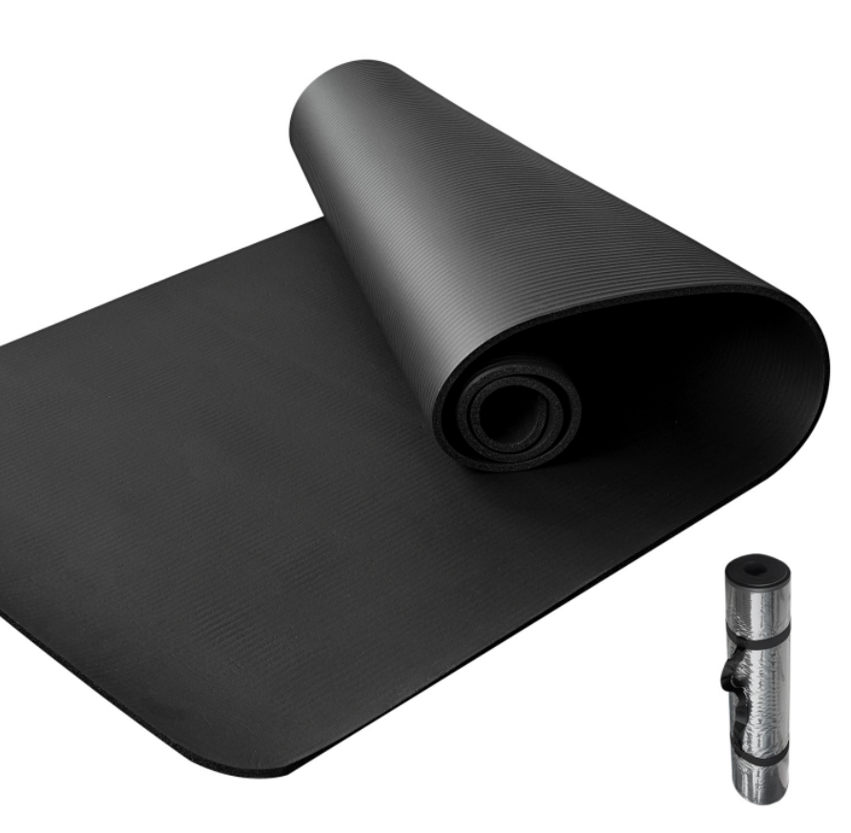

About this item
- DOUBLE SIDED yoga mat provides optimal grip and non-slip texture prevents injuries and suitable for all floor based exercises.
- EASY TRANSPORT & STORAGE, handy carrying straps and lightweight features help you bring your mat to gym or anywhere you want easily. Size: 183*61CM
- MOISTURE RESISTANT technology allows your mat to be easily washed with soap and water.
- DURABLE yoga mat is suitable for long term use and with exclusive thick memory foam ensures your comfort and protects your joints, spine, hips, knees and elbows on hard floors
- MULTI PURPOSE USAGE: You can use our mats for Yoga, or during your daily exercises and workouts. Make your own gym at home

Technical Details
Color | ‎Black
Material type | ‎Memory Foam
Brand | ‎LMS Data
Manufacturer | ‎Dynamode
ASIN | ‎B09BMMSFB6

Additional Information
Date First Available | 2 Aug. 2021

Part number: YOGA-MAT-BLK

